Freedom
To vote in all elections without punitive restriction
To choose your religion
To choose whom you marry
To make your own health care choices
From injustice
From unscrupulous banking practices
From persecution and racism
From Big Money in Government
From fear, with Gun safety rules that protect you
From fear of devastating climate change
For women to make their own reproductive health choices
Opportunity
To vote as you choose
To live the American dream
To live in affordable housing
To attend college that is affordable
For good paying jobs that support your family
For immigrants to contribute to our society
From an economy that works for all
Afforded by
- quality education
- a progressive, fair tax system
- a court system that enforces contracts and laws
- a fair and ethical government
Security
Having a safe place to live
Having a well-trained military & police
Having a foreign policy that is guided by hopes of future generations
Having clean air and water
Having pure food and drugs
Having up-to-date and safe infrastructure
Having accessible health care for all
Having a strong safety net including
- enhanced Social Security
- expanded Medicare
- extended Medicaid
- unemployment insurance
- SNAP & TANF

The Democrats’ Agenda for America
- Equal pay for equal work
- Reduce student debt
- Opportunities for women to advance
- Economic policies that support job growth
- Support renewable energy
- Reduce carbon emissions
- Support science-based environmental policy
- Protect Medicare and Medicaid
- Rebuild America by investing in infrastructure
- Improve neighborhood public schools
- Three month’s paid family and maternity leave
- Raise taxes on the top 1%
- Limit skyrocketing CEO pay
- Defend the right of workers to bargain
- Increase the national minimum wage to $15 per hour
- Oppose trade agreements that export American jobs
- Break up big banks that are “too big to fail”
- Fair and accessible voting for every eligible voter
- Accessible health care for all
- Effective gun safety policies

Democrats are working for Freedom, Opportunity, and Security for all Americans!

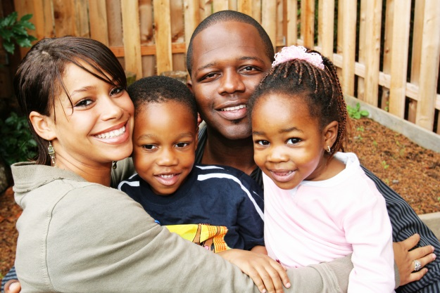
Contact us at
www.democratsofdawsoncounty.org
dawsoncountydemocrats@gmail.com
https://www.facebook.com/DawsonCountyDemocraticParty
Bette Holland, Chair

Good government guarantees our liberty
Liberty means freedom, opportunity, and security for all!
Are these values important to you and your family?

There is one organization that works for these values for all Americans.
Read this pamphlet for more information!

